# Custom Css Selectors

If we have to locate the elements based on the attribute value, then

* we can use **^=** attribute selector to match the attribute values**starting** with the specified text.
* we can use **$=** attribute selector to match the attribute values **ending** with the specified text.
* we can use **\*=** attribute selector to match the attribute values containing the specified text any where in the attribute values.

Type 1  
First lets use **^=** attribute selector by following the below steps:

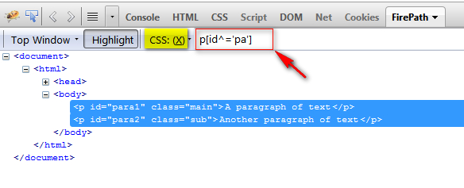

3. Observe that all the paragraph elements having the id attribute value starting with 'pa' text got highlighted as shown below:

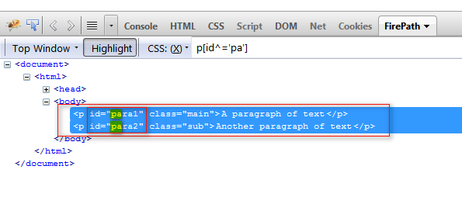

4. Now enter the CSS path **p[class^='m']** into the text box as shown below and click on 'Eval' button:

[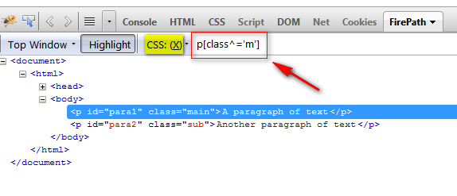](http://1.bp.blogspot.com/-YTA7XSQXDnA/UXpYOe7GIHI/AAAAAAAASH4/YwaX7XQk8bs/s1600/3.jpg)

5. Observe that all the paragraph elements having the class attribute value starting with 'm' text got highlighted as shown below:

[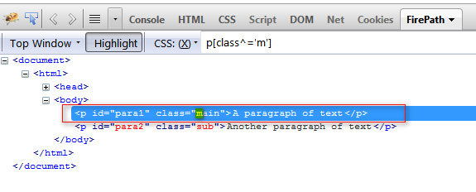](http://3.bp.blogspot.com/-eKHAw6DIZXo/UXpYfzgS8-I/AAAAAAAASIA/-JLD4jZyCTU/s1600/4.jpg)

# Type 2

Now lets use **$=** attribute selector by following the below steps:

[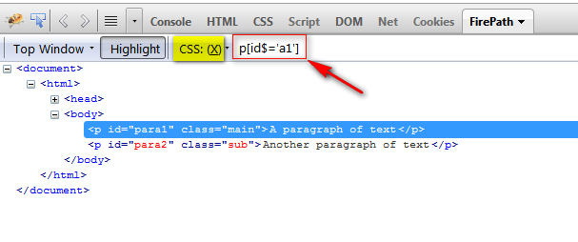](http://3.bp.blogspot.com/-KW98bYVWbYU/UXpZEOPM8KI/AAAAAAAASII/NhtevM-XudM/s1600/5.jpg)

3. Observe that the paragraph elements having the id attribute value ending with 'a1' text got highlighted as shown below:

[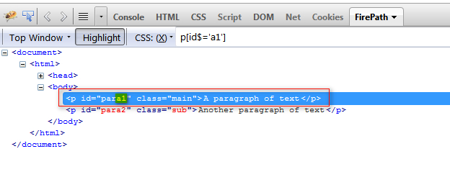](http://2.bp.blogspot.com/-njehFFm0TY8/UXpZi2mzzVI/AAAAAAAASIQ/_nsLiuMClxQ/s1600/6.jpg)

4. Now enter the CSS path **p[class$='b']** into the text box as shown below and click on 'Eval' button:

[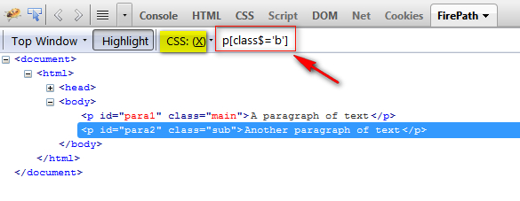](http://3.bp.blogspot.com/-6GqPrGcRRGE/UXpZ41XifvI/AAAAAAAASIY/ylRDZDbqmMA/s1600/7.jpg)

5. Observe that the paragraph elements having the class attribute value ending with 'b' text got highlighted as shown below:

[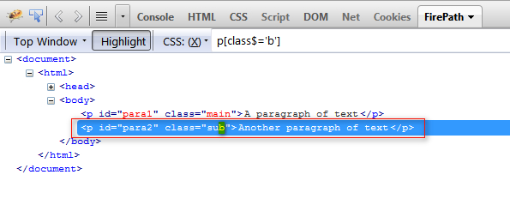](http://1.bp.blogspot.com/-U239v5rvGO8/UXpaJGDj8II/AAAAAAAASIg/fdPqW8E-3UQ/s1600/8.jpg)

# Type 3

Now lets use **\*=** attribute selector by following the below steps:

[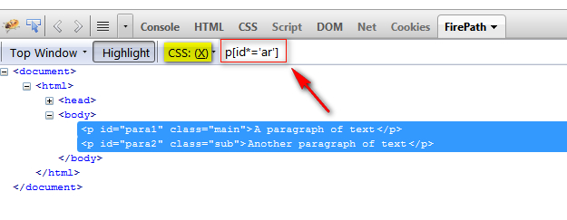](http://1.bp.blogspot.com/-eNAWQfpyUu4/UXpanaSNNiI/AAAAAAAASIo/J5lZnBHTjKg/s1600/9.jpg)

3. Observe that all the paragraph elements having the id attribute value containing 'ar' text any where in the attribute  value got highlighted as shown below:

[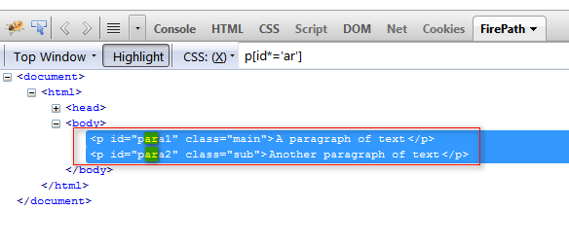](http://4.bp.blogspot.com/-zD-9l8MghjE/UXpa96ggtcI/AAAAAAAASIw/kuqbTx9JpX0/s1600/10.jpg)

4. Now enter the CSS path **p[class*='a']** into the text box as shown below and click on 'Eval' button:

[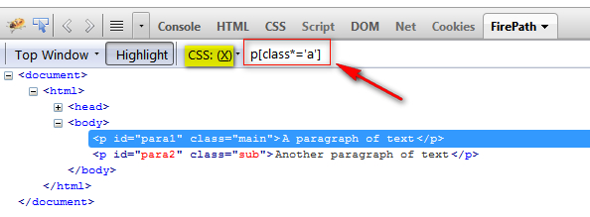](http://2.bp.blogspot.com/-Saw1eP74u-4/UXpbPq50-HI/AAAAAAAASI4/QSucBG-vWnY/s1600/11.jpg)

5. Observe that all the paragraph elements having the class attribute value containing 'a' text any where in the attribute value got highlighted as shown below:

[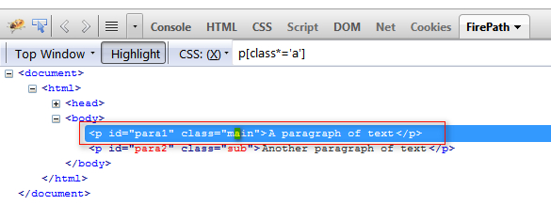](http://1.bp.blogspot.com/-XYyqXExxoIw/UXpbgkKUZsI/AAAAAAAASJA/r53Kv0X7Cx0/s1600/12.jpg)

So we have used ^= , $= and *= attribute selectors in CSS path.